MAT 303 Module One Problem Set Report

Multiple Regression

Sarah Warden
Sarah.warden1@snhu.edu
Southern New Hampshire University

Introduction

The data set we are working with for this project contains information on different vehicles in order to predict miles per gallon based on changes to the rear axle ratio and horsepower. The goal is to make tweaks to the independent variables (rear axle ratio and horsepower) to find a great final model without jeopardizing the fuel economy of the vehicles. In order to ensure our data has a strong linear relationship and has limited multicollinearity. We will do this by running a residual plot to check the linearity and homoscedastic assumptions, along with a Q-Q plot to determine normality. Finally, we will run multiple regression analysis to ensure the independent variables are necessary and not dependent on each other.

Data Preparation

In our data set, we will be focusing on three distinct variables: rear axle ratio, horsepower, and miles per gallon. The independent variables are the rear axle ratio, denoted as column “drat”, and horsepower, denoted as column “hp”. Independent variables are used to predict the dependent variable, which is miles per gallon, denoted as column “mpg”. We can see that there are 12 total columns, meaning we have a total of 12 different categories of data. Finally, we have 32 rows, which means that we have a sample size of 32 vehicles.

Multiple Regression Model

Correlation Analysis

The Pearson Correlation Coefficient (PCC) between an independent variable and a dependent variable can tell us the level of a linear relationship, which in turn shows how well you can predict the dependent variable from the independent one. Based on the tests run on our data set, I found that the PCC between miles per gallon and rear axle ratio is 0.68. The positive value above 0.5 shows a strong positive correlation between the two variables. Next, I looked at miles per gallon against horsepower. The PCC for this relationship is -0.78. Again, we can see a strong relationship, yet the negative value shows a negative correlation. Since both PCC values are strong, we can conclude that each independent variable is a strong predictor of miles per gallon. I have included the scatter plots of fuel efficiency against rear axle ratio and horsepower below for visual representation.

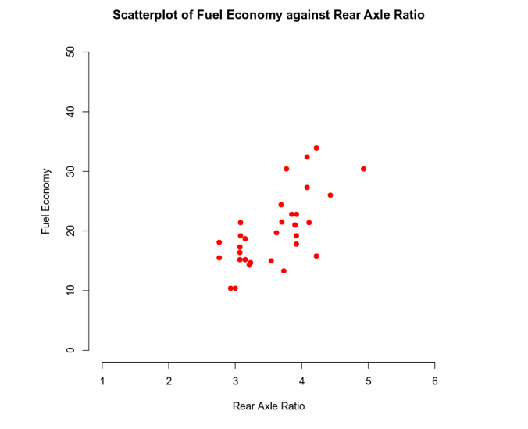

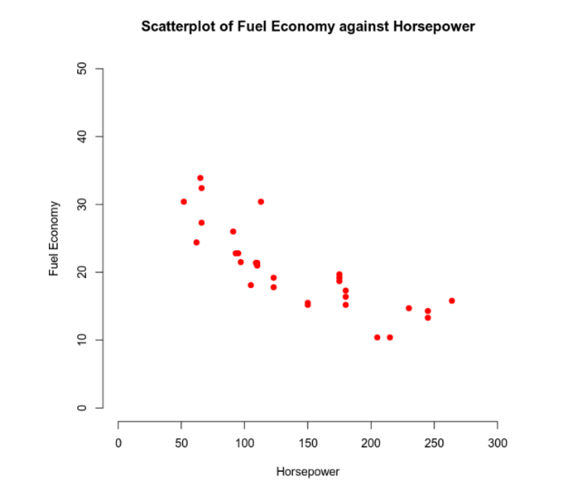

Reporting Results

The general form equation I will be plugging the values from our data set into is as follows:
$E\left(Y\right)= {\text{β}}_{0}+β_{1}X_{1}+β_{2}X_{2}$. Once we substitute in our own values, we get the multiple regression model specific to our problem. That equation is as follows: $E\left(Y\right)=10.79+4.70X_{1}-0.05X_{2}$ where $X_{1}$= rear axle ratio (drat) and $X_{2}$ = horsepower (hp). Next, we will evaluate the values of $R^{2}=0.74$ and $R_{adj}^{2}=0.72$. The value of $R^{2}$ tells us that 74% of the variance in fuel efficiency can be attributed to the variables of rear axle ratio and horsepower. Furthermore, since $R_{adj}^{2}≥R^{2}$, which tells us that the addition of another independent variable will not necessarily improve the level of variance.
Looking at our multiple regression model equation, we can see that the fuel efficiency increases by 4.70 mpg for each unit increase in the rear axle ratio. Conversely, the fuel efficiency decreases by 0.05 mpg for each additional horsepower. A fitted value, represented by $Ŷ$, is the predicted value of the $i^{th}$ value of Y. Meanwhile, a residual value is the difference between the actual value and the fitted value for the $i^{th}$term. Next, I created a residual and Q-Q plot to check against the multiple regression assumptions and ensure that our variables and model equation are a great fit. As we can see, there is no real pattern to the Residuals Plot, showing that there is a strong linear relationship between our variables. In the Q-Q Plot, the residual plot points are reasonably close to the regression line, showing that the assumption of normality holds within our data set. I have included the plots below for visual representation.

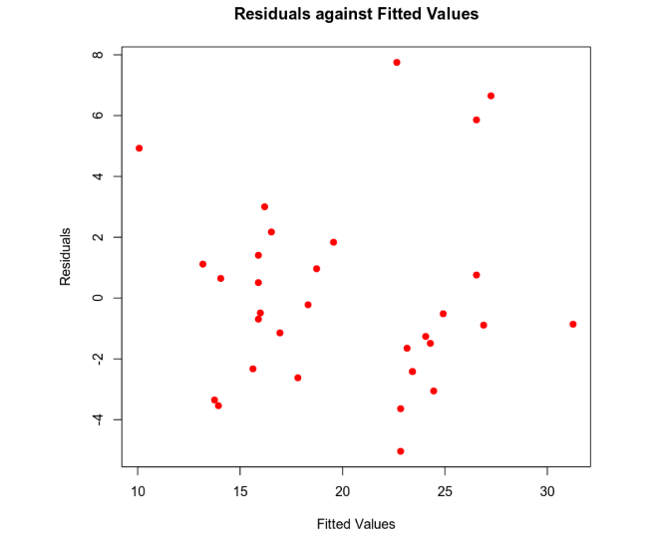

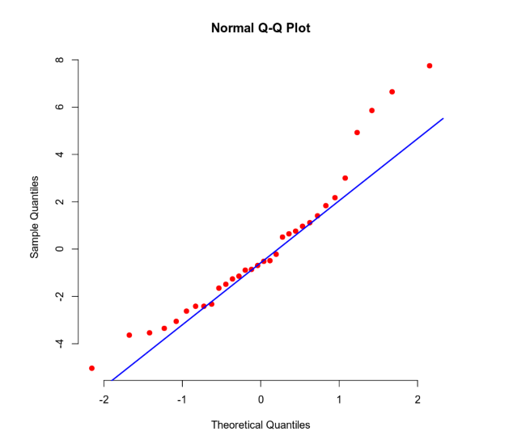

Evaluating Model Significance

In order to check that our model is significant at a 5% level, we must run an Overall F-test and an Individual t-test. For the Overall F-test, our initial hypothesis is $H_{0}=β_{1}=β_{2}=0$, with our alternate hypothesis being $H_{a}$ = at least one $β_{i}≠0$. In our scenario, the p-value of 3.081e-09 is less than our significance level of 0.05, so we can reject the original hypothesis. Next, we look at the Individual t-test. In this situation, our initial hypothesis is $H_{0}= β_{i}=0$ for $i=1$ or $i=2$. Our alternate hypothesis is $H_{a}=β_{i}≠0$. First, we look at the t-value and p-value for the rear axle ratio. In this instance, our t-value is 3.94 with a corresponding p-value of $4.67x{10}^{-4}$. With our second variable, horsepower, we have a t-value of -5.57 with a corresponding p-value of $5.17x{10}^{-6}$. In both instances, the p-value is less than our significance level, so both initial hypotheses are rejected. All these tests show that our variables have a statistically significant linear relationship.
Finally, I looked at the confidence intervals. I can say with 95% certainty that the rear axle ratio will be between 2.26 and 7.14, while the horsepower will fall between -0.07 and -0.03.

Making Predictions Using the Model

In order to make predictions of fuel efficiency, we must refer back to the multiple regression model. For ease of reference, I have rewritten it here: $E\left(Y\right)=10.79+4.70X_{1}-0.05X_{2}$ where $X_{1}$ = rear axle ratio and $X_{2}$ = horsepower. If we want to predict the fuel efficiency for a car that has a rear axle ratio of 3.15 and a horsepower of 120, we simply plug these values into our equation and solve. $E\left(Y\right)=10.79+4.70\left(3.15\right)-0.05\left(120\right)=19.60$.
Now, if we assume that, in actuality, this car has an average miles per gallon of 20.5, the residual value would be 20.5 – 19.6 = 0.9. Using the same car as above, our 95% prediction interval has the fuel efficiency falling between 12.64 and 26.10. Our 95% confidence interval is between 17.57 and 21.18. It is important to note that the prediction interval is always larger than the confidence interval, as it considers the uncertain nature of the model, and the confidence interval does not.

Conclusion

Utilizing the analysis that I have performed on our data set, I would recommend using this model. Using the residual plots and Q-Q plots, we know that all our multiple regression model assumptions hold true. On top of that, our sample size, while on the smaller side, is still statistically significant to run regression models on (it should be at least 30). When we used our model equation to predict the fuel efficiency of a specific vehicle, our prediction fell well within our 95% confidence interval. All this goes to say that, utilizing the multiple regression model held within this report, we can confidently predict the fuel efficiency in miles per gallon based on a known rear axle ratio and the horsepower of a vehicle. With this knowledge, we can change those variables to create the best car for our customers while maintaining an acceptable fuel efficiency for our environment.

